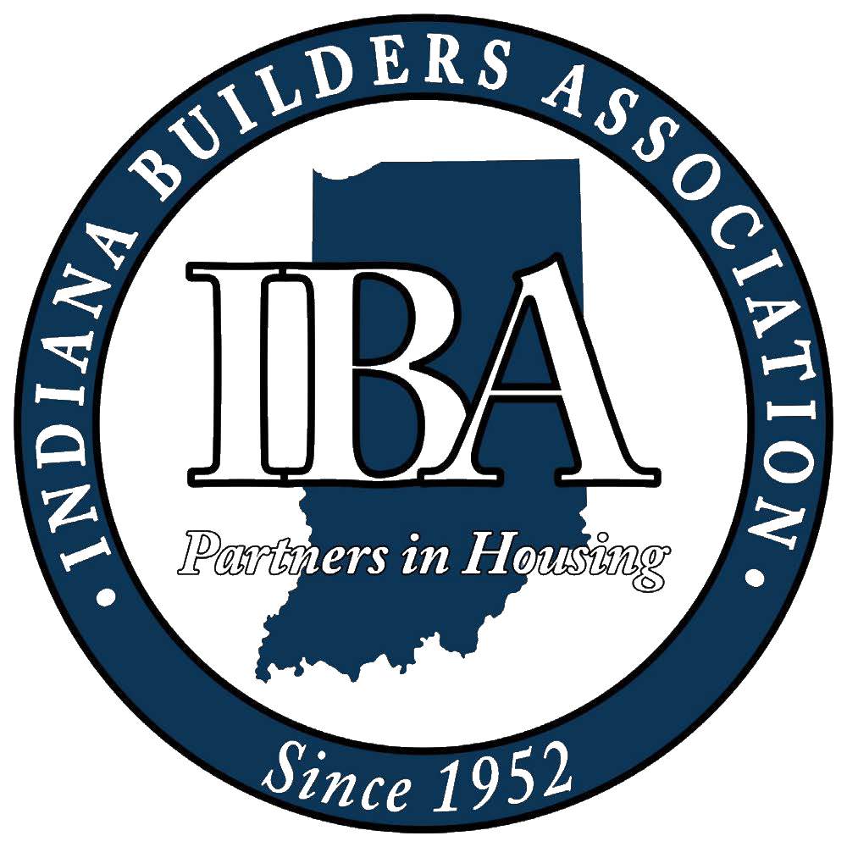

2024 State & National Association Calendar of Events

Date | Event | Location
January 17 | Webinar: Using AI to Track Local Government Action on Housing Issues | Zoom
January 24 | Webinar: USDA Loan Programs for Rural Housing | Zoom
January 29 – 30 | IBA Legislative Conference | Hyatt Regency Indianapolis, Indianapolis, IN
February 27 - 29 | NAHB International Builders’ Show (IBS) | Las Vegas Convention Center, Las Vegas, NV
February 28 | Networking Night at IBS | Jimmy Kimmel’s Comedy Club, Las Vegas, NV
March 27 | IBA Executive Committee Meeting | Indiana Builders Association, Indianapolis, IN
April 22-24 | Certified Aging-in-Place Specialist (CAPS) Program | Northend Community Center, Lafayette, IN
May 16 | Residential Code Training | The Wellington Banquet & Conference Center, Fishers, IN
May 22 | IBA Executive Committee Meeting | Zimmer Biomet Center Lake Pavilion, Warsaw, IN
June 11 - 14 | NAHB Spring Leadership Meeting and Legislative Conference | Marriott Marquis, Washington, D.C.
July 31 | IBA Executive Committee Meeting | Carr Workplaces, West Lafayette, IN
August 22 | NAHB BUILD-PAC Golf Outing | Evansville Country Club, Evansville, IN
September 18 | IBA Executive Committee Meeting | Haubstadt Gym, Haubstadt, IN
October 1- 3 | NAHB Fall Leadership Meeting | JW Marriott San Antonio Hill Country Resort & Spa, San Antonio, Texas
October 10 | Certified Lead Renovator Training | TBD
October 21 - 23 | Certified Aging-in-Place Specialist (CAPS) Program | Evansville, IN
November 20 - 21 | IBA Annual Conference | TBD
 |  | *as of 02/16/2024*

